Database Systems
Quiz II
Time allowed 15 min

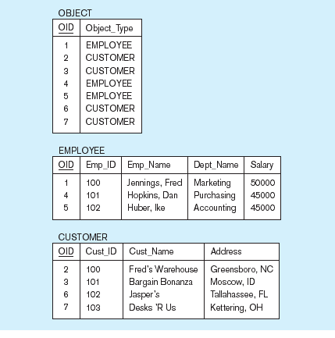
Q1. Write a query for:
- Displaying object ID, Object type and names of all objects when the object type is employee.

O_Id |  | OrderDate | OrderPrice | Customer
1 |  | 2008/11/12 | 1000 | Hansen
2 |  | 2008/10/23 | 1600 | Nilsen
3 |  | 2008/09/02 | 700 | Hansen
4 |  | 2008/09/03 | 300 | Hansen
5 |  | 2008/08/30 | 2000 | Jensen
6 |  | 2008/10/04 | 100 | Nilsen
Q2. Write ouptput for the following query:

- SELECT Customer,SUM(OrderPrice) FROM Orders GROUP BY Customer;

- SELECT
TO_CHAR(TO_DATE('04-JUL-15', 'DD-MON-RR'), 'DD-MON-YYYY'),
TO_CHAR(TO_DATE('04-JUL-75', 'DD-MON-RR'), 'DD-MON-YYYY')
FROM dual;

